# VISVESVARAYA TECHNOLOGICAL UNIVERSITY

## BELAGAVI – 590018, Karnataka INTERNSHIP REPORT

#### ON

“Virtual Assistant for Visual Impaired using ML”

***Submitted in partial fulfilment for the award of degree(18CSI85)***

## BACHELOR OF ENGINEERING IN

## COMPUTER SCIENCE

***Submitted by:***

#### GURURAJ H K

#### 1AK19CS014



Conducted at

**SAIN INFORMATIX**



# AKSHAYA INSTITUTE OF TECHNOLOGY

**Department of Computer Science**

**Accredited by NBA, New Delhi**

# Oblapura Post,Koratagere Road,Tumkur-572 106

# AKSHAYA INSTITUTE OF TECHNOLOGY

**Department of Computer Science**

**Accredited by NBA, New Delhi**

# Oblapura Post,Koratagere Road,Tumkur-572 106



**CERTIFICATE**

This is to certify that the Internship titled **“Virtual Assistant for Visual Impared using ML”** carried out by **Ms Nandini,** a bonafide student of Akshaya Institute of Technology, in partial fulfillment for the award of **Bachelor of Engineering**, in **COMPUTER SCIENCE** under Visvesvaraya Technological University, Belagavi, during the year 2022-2023. It is certified that all corrections/suggestions indicated have been incorporated in the report.

The project report has been approved as it satisfies the academic requirements in respect of Internship prescribed for the course Internship / Professional Practice (18CSI85)

#### Signature of Guide Signature of HOD Signature of Principal

**External Viva:**

Name of the Examiner Signature with Date

1)

2)

# D E C L A R A T I O N

I, **Gururaj Kondaguli**, final year student of Computer Science,Akshaya Institute of Technology – 572-106, declare that the Internship has been successfully completed, in **SAIN INFORMATIX**. This report is submitted in partial fulfillment of the requirements for award of Bachelor Degree in Computer Science and Engineering, during the academic year 2022-2023.

Date : 10/Apr/2023 :

Place : Tumakuru

USN : 1AK19CS014

NAME : Gururaj Kondaguli

**OFFER LETTER**

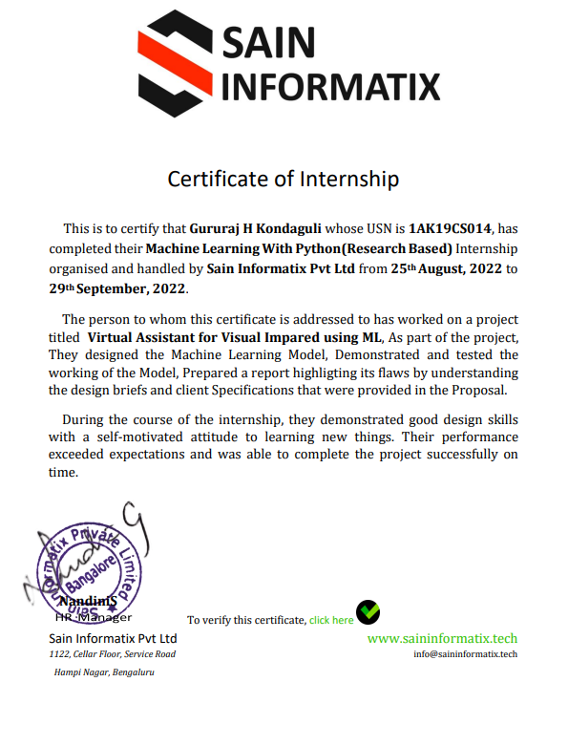

# A C K N O W L E D G E M E N T

This Internship is a result of accumulated guidance, direction and support of several important persons. We take this opportunity to express our gratitude to all who have helped us to complete the Internship.

We express our sincere thanks to our Principal, for providing us adequate facilities to undertake this Internship.

We would like to thank our Head of Dept – branch code, for providing us an opportunity to carry out Internship and for his valuable guidance and support.

We would like to thank our (Lab assistant name) Software Services for guiding us during the period of internship.

We express our deep and profound gratitude to our guide, Guide name, Assistant/Associate Prof, for her keen interest and encouragement at every step in completing the Internship.

We would like to thank all the faculty members of our department for the support extended during the course of Internship.

We would like to thank the non-teaching members of our dept, forhelping us during the Internship.

Last but not the least, we would like to thank our parents and friends without whose constant help, the completion of Internship would have not been possible.

**GURURAJ H K**

**1AK19CS014**

# ABSTRACT

Interacting with mobile applications can often be challenging for people with visual impairments due to the poor usability of some mobile applications. The goal of this paper is to provide an overview of the developments on usability of mobile applications for people with visual impairments based on recent advances in research and application development. This overview is important to guide decision-making for researchers and provide a synthesis of available evidence and indicate in which direction it is worthwhile to prompt further research. We performed a systematic literature review on the usability of mobile applications for people with visual impairments. A deep analysis following the Preferred Reporting Items for SLRs and Meta- Analyses (PRISMA) guidelines was performed to produce a set of relevant papers in the field. We first identified 932 papers published within the last six years. After screening the papers and employing a snowballing technique, we identified 60 studies that were then classified into seven themes: accessibility, daily activities, assistive devices, navigation, screen division layout, and audio guidance. The studies were then analyzed to answer the proposed research questions in order to illustrate the different trends, themes, and evaluation results of various mobile applications developed in the last six years. Using this overview as a foundation, future directions for research in the field of usability for the visually impaired (UVI) are highlighted

–

# Table of Contents

|  |  |  |
| --- | --- | --- |
| **Sl no** | **Description** | **Page no** |
| 1 | Company Profile |  |
| 2 | About the Company |  |
| [3](https://1.bp.blogspot.com/-dODuK8N5h1Q/Wlnyb3V9HFI/AAAAAAAACL4/WxQtCJ1pM5wccDABg4wIrTBUB0vlikXQQCLcBGAs/s1600/poly1.jpg) | Introduction |  |
| [4](https://1.bp.blogspot.com/-dODuK8N5h1Q/Wlnyb3V9HFI/AAAAAAAACL4/WxQtCJ1pM5wccDABg4wIrTBUB0vlikXQQCLcBGAs/s1600/poly1.jpg) | Requirement Analysis |  |
| 5 | [Implementation](https://4.bp.blogspot.com/-IOOxgPaXMVc/Wlj3LWvcnjI/AAAAAAAACKE/UeTFYvAxDmUDel5UBjdifeWaApB3-dXVgCLcBGAs/s1600/img1.jpg) |  |
| 6 | Snapshots |  |
| 7 | Conclusion |  |
| 8 | References |  |

[**CHAPTER**](https://1.bp.blogspot.com/-dODuK8N5h1Q/Wlnyb3V9HFI/AAAAAAAACL4/WxQtCJ1pM5wccDABg4wIrTBUB0vlikXQQCLcBGAs/s1600/poly1.jpg) **1** **COMPANY PROFILE**

# COMPANY PROFILE

## A Brief History of Sain Informatix

Sain Informatix, was incorporated with a goal ”To provide high quality and optimal Technological Solutions to business requirements of our clients”. Every business is a different and has a unique business model and so are the technological requirements. They understand this and hence the solutions provided to these requirements are different as well. They focus on clients requirements and provide them with tailor made technological solutions. They also understand that Reach of their Product to its targeted market or the automation of the existing process into e-client and simple process are the key features that our clients desire from Technological Solution they are looking for and these are the features that we focus on while designing the solutions for their clients.

Sarvamoola Software Services. is a Technology Organization providing solutions for all web design and development, MYSQL, PYTHON Programming, HTML, CSS, ASP.NET and LINQ. Meeting the ever increasing automation requirements, Sarvamoola Software Services. specialize in ERP, Connectivity, SEO Services, Conference Management, effective web promotion and tailor-made software products, designing solutions best suiting clients requirements.

Sain Informatix, strive to be the front runner in creativity and innovation in software development through their well-researched expertise and establish it as an out of the box software development company in Bangalore, India. As a software development company, they translate this software development expertise into value for their customers through their professional solutions.

They understand that the best desired output can be achieved only by understanding the clients demand better. Sain Informatix work with their clients and help them to defiine their exact solution requirement. Sometimes even they wonder that they have completely redefined their solution or new application requirement during the brainstorming session, and here they position themselves as an IT solutions consulting group comprising of high caliber consultants.

They believe that Technology when used properly can help any business to scale and achieve new heights of success. It helps Improve its efficiency, profitability, reliability; to put it in one sentence ” Technology helps you to Delight your Customers” and that is what we want to achieve.

# [CHAPTER](https://1.bp.blogspot.com/-dODuK8N5h1Q/Wlnyb3V9HFI/AAAAAAAACL4/WxQtCJ1pM5wccDABg4wIrTBUB0vlikXQQCLcBGAs/s1600/poly1.jpg) 2 ABOUT THE COMPANY

1. **ABOUT THE COMPANY**



Sain Informatix is a Technology Organization providing solutions for all web design and development, MYSQL, PYTHON Programming, HTML, CSS, ASP.NET and LINQ. Meeting the ever increasing automation requirements,Sain Informatix specialize in ERP, Connectivity, SEO Services, Conference Management, effective web promotion and tailor-made software products, designing solutions best suiting clients requirements. The organization where they have a right mix of professionals as a stakeholders to help us serve our clients with best of our capability and with at par industry standards. They have young, enthusiastic, passionate and creative Professionals to develop technological innovations in the field of Mobile technologies, Web applications as well as Business and Enterprise solution. Motto of our organization is to “Collaborate with our clients to provide them with best Technological solution hence creating Good Present and Better Future for our client which will bring a cascading a positive effect in their business shape as well”. Providing a Complete suite of technical solutions is not just our tag line, it is Our Vision for Our Clients and for Us, We strive hard to achieve it.

## Products of Sain Informatix.

**Android Apps**

It is the process by which new applications are created for devices running the Android operating system. Applications are usually developed in Java (and/or Kotlin; or other such option) programming language using the Android software development kit (SDK), but other development environments are also available, some such as Kotlin support the exact same Android APIs (and bytecode), while others such as Go have restricted API access.

The Android software development kit includes a comprehensive set of development tools. These include a debugger, libraries, a handset emulator based on QEMU, documentation, sample code, and zutorials. Currently supported development platforms include computers running Linux (any modern desktop Linux distribution), Mac OS X 10.5.8 or later, and Windows 7 or later. As of March 2015, the SDK is not available on Android itself, but softwaredevelopment is possible by using specialized Android applications.

**Web Application**

It is a client–server computer program in which the client (including the user interface and client- side logic) runs in a web browser. Common web applications include web mail, online

retail sales, online auctions, wikis, instant messaging services and many other functions. web applications use web documents written in a standard format such as HTML and JavaScript,which are supported by a variety of web browsers. Web applications can be considered as a specifific variant of client–server software where the client software is downloaded to the client machine when visiting the relevant web page, using standard procedures such as HTTP. The Client web software updates may happen each time the web page is visited. During the session, the web browser interprets and displays the pages, and acts as the universal client for any web application. The use of web application frameworks can often reduce the number of errors in a program, both by making the code simpler, and by allowing one team to concentrate on the framework while another focuses on a specifified use case. In applications which are exposed to constant hacking attempts on the Internet, security- related problems can be caused by errors in the program.

Frameworks can also promote the use of best practices such as GET after POST. There are some who view a web application as a two-tier architecture. This can be a “smart” client that performs all the work and queries a “dumb” server, or a “dumb” client that relies on a “smart” server. The client would handle the presentation tier, the server would have the database (storage tier), and the business logic (application tier) would be on one of them or on both. While this increases the scalability of the applications and separates the display and the database, it still doesn‟t allow for true specialization of layers, so most applications will outgrow this model. An emerging strategy for application software companies is to provide web access to software previously distributed as local applications. Depending on the type of application, it may require the development of an entirely different browser-based interface, or merely adapting an existing application to use different presentation technology. These programs allow the user to pay a monthly or yearly fee for use of a software application without having to install it on a local hard drive. A company which follows this strategy is known as an application service provider (ASP), and ASPs are currently receiving much attention in the software industry.

Security breaches on these kinds of applications are a major concern because it can involve both enterprise information and private customer data. Protecting these assets is an important part of any web application and there are some key operational areas that must be included in the development process. This includes processes for authentication, authorization, asset handling, input, and logging and auditing. Building security into the applications from the beginning can be more effective and less disruptive in the long run.

**Web design**

It is encompasses many different skills and disciplines in the production and maintenance of websites. The different areas of web design include web graphic design; interface design; authoring, including standardized code and proprietary software; user experience design; and

search engine optimization. The term web design is normally used to describe the design process relating to the front-end (client side) design of a website including writing mark up. Web design partially overlaps web engineering in the broader scope of web development. Web designers are expected to have an awareness of usability and if their role involves creating mark up then they are also expected to be up to date with web accessibility guidelines. Web design partially overlaps web engineering in the broader scope of web development.

## Departments and services offered

Sain Informatix plays an essential role as an institute, the level of education, development of student’s skills are based on their trainers. If you do not have a good mentor then you may lag in many things from others and that is why we at Sain Informatix gives you the facility of skilled employees so that you do not feel unsecured about the academics. Personality development and academic status are some of those things which lie on mentor’s hands. If you are trained well then you can do well in your future and knowing its importance of Sain Informatix always tries to give you the best.

They have a great team of skilled mentors who are always ready to direct their trainees in the best possible way they can and to ensure the skills of mentors we held many skill development programs as well so that each and every mentor can develop their own skills with the demands of the companies so that they can prepare a complete packaged trainee.

## Services provided by Sain Informatix.

* Core Java and Advanced Java
* Web services and development
* Dot Net Framework
* Python
* Selenium Testing
* Conference / Event Management Service
* Academic Project Guidance
* On The Job Training
* Software Training

# [CHAPTER](https://1.bp.blogspot.com/-dODuK8N5h1Q/Wlnyb3V9HFI/AAAAAAAACL4/WxQtCJ1pM5wccDABg4wIrTBUB0vlikXQQCLcBGAs/s1600/poly1.jpg) 3 INTRODUCTION

1. **INTRODUCTION**

## Introduction to ML

According to the World Health Organization, there are approximately 285 million people who are visual impairments, 39 million of them are blind and 246 million have a decrease of Visual acuity. Almost 90% who are visually impaired are living in low-income countries.

In this context,Tunisia has identified 30,000 people with visual impairments; including 13.3% of them are blind. These Visual impairment present severe consequences on certain capabilities related to visual function: − The daily living activities (that require a vision at a medium distance) −Communication,reading, writing (which requires a vision closely and average distance) − Evaluation of space and the displacement (which require a vision far) − The pursuit of an activity requiring prolongedmaintenance of visual attention. In the computer vision community, developing visual aids for handicapped persons is one of the most active research projects. Mobility aids are intended to describe the environment close to the person with an appreciation of the surrounding objects.

These aids are essential for fine navigation in an environment described in a coordinate system relative to the user. In this paper, we present an overview of vision substitution modalities [1-12] and their functionalities. Then, we introduce our proposed system and the experiments tests.

# [CHAPTER](https://1.bp.blogspot.com/-dODuK8N5h1Q/Wlnyb3V9HFI/AAAAAAAACL4/WxQtCJ1pM5wccDABg4wIrTBUB0vlikXQQCLcBGAs/s1600/poly1.jpg) 4 REQUIREMENT ANALYSIS

**4. REQUIREMENT ANALYSIS**

## Hardware Requirement Specification

* + - 1. Pentium Processor IV or Higher
      2. Min 10 GB HDD
      3. RAM 512 MB or Higher
      4. 2.4 GHz or faster Processor

## Software Requirement Specification

* + - 1. Windows Vista onwards, Linux, Mac OS
      2. In the case of building the Project from the source
      3. Python Compiler
      4. Tensorflow Machine learning library
      5. Keras
      6. SciKit Learn
      7. Pandas
      8. Numpy
      9. Flask

# [CHAPTE](https://1.bp.blogspot.com/-dODuK8N5h1Q/Wlnyb3V9HFI/AAAAAAAACL4/WxQtCJ1pM5wccDABg4wIrTBUB0vlikXQQCLcBGAs/s1600/poly1.jpg)R 5 IMPLEMENTATION

**5 .IMPLEMENTATION**

Implementation is the stage where the theoretical design is turned into a working system. The most crucial stage in achieving a new successful system and in giving confidence on the new system for the users that it will work efficiently and effectively.

The system can be implemented only after thorough testing is done and if it is found to work according to the specification. It involves careful planning, investigation of the current system and it constraints on implementation, design of methods to achieve the change over and an evaluation of change over methods a part from planning.

Two major tasks of preparing the implementation are education and training of the users and testing of the system. The more complex the system being implemented, the more involved will be the system analysis and design effort required just for implementation.

The implementation phase comprises of several activities. The required hardware and software acquisition is carried out. The system may require some software to be developed. For this, programs are written and tested. The user then changes over to his new fully tested system and the old system is discontinued.

## TESTING

The testing phase is an important part of software development. It is the Information zed system will help in automate process of finding errors and missing operations and also a complete verification to determine whether the objectives are met and the user requirements are satisfied. Software testing is carried out in three steps:

1. The first includes unit testing, where in each module is tested to provide its correctness, validity and also determine any missing operations and to verify whether the objectives have been met. Errors are noted down and corrected immediately.
2. Unit testing is the important and major part of the project. So errors are rectified easily in particular module and program clarity is increased. In this project entire system is divided into several modules and is developed individually. So unit testing is conducted to individual modules.
3. The second step includes Integration testing. It need not be the case, the software whose modules when run individually and showing perfect results, will also show perfect results when run as a whole.

# [CHAPTE](https://1.bp.blogspot.com/-dODuK8N5h1Q/Wlnyb3V9HFI/AAAAAAAACL4/WxQtCJ1pM5wccDABg4wIrTBUB0vlikXQQCLcBGAs/s1600/poly1.jpg)R 6 SNAPSHOTS

**6.SNAPSHOTS**

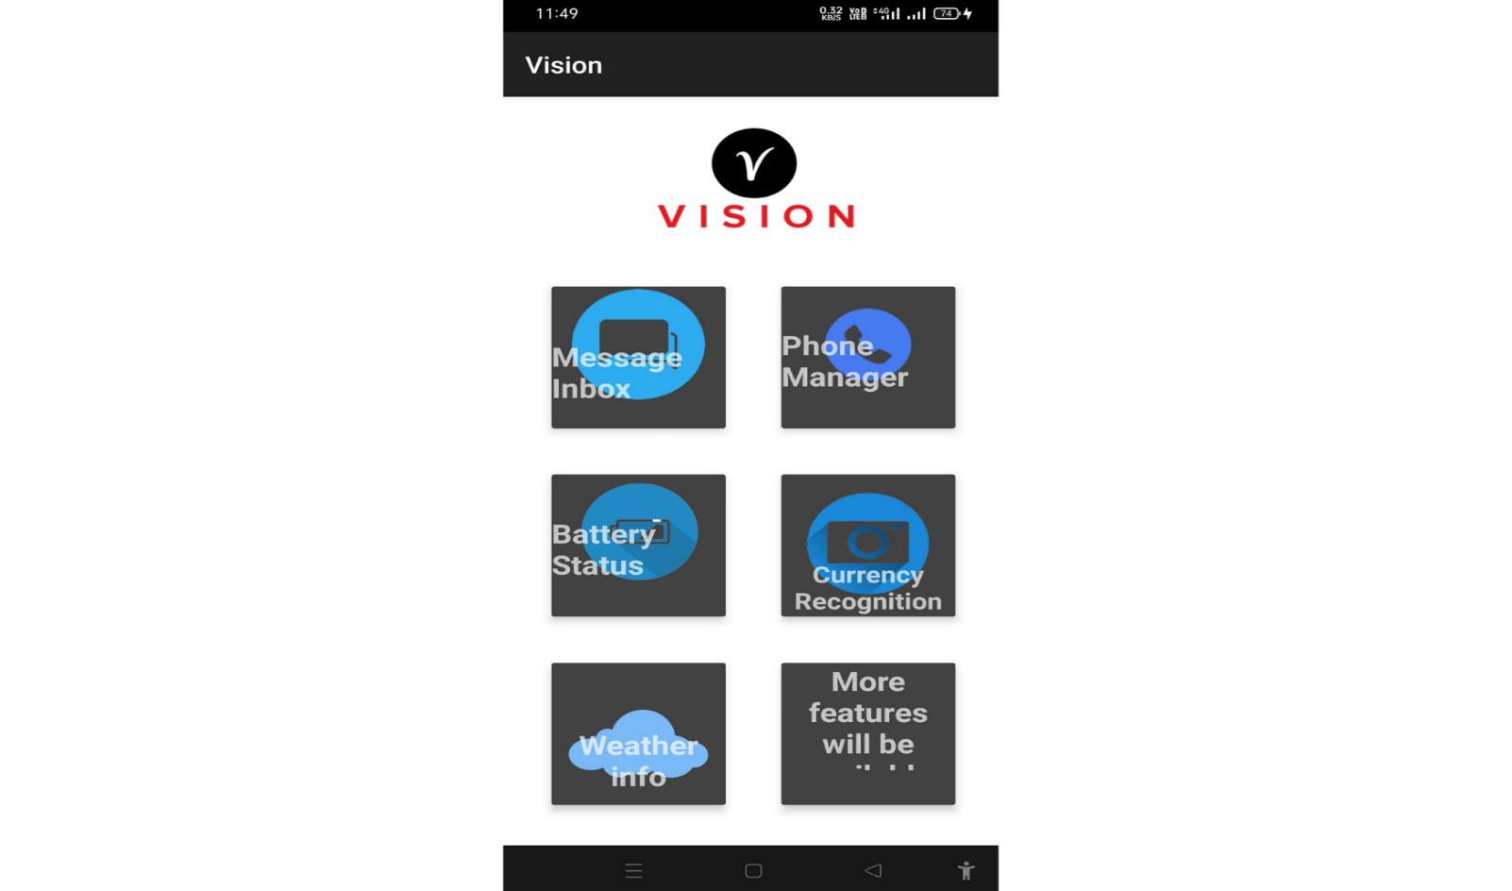

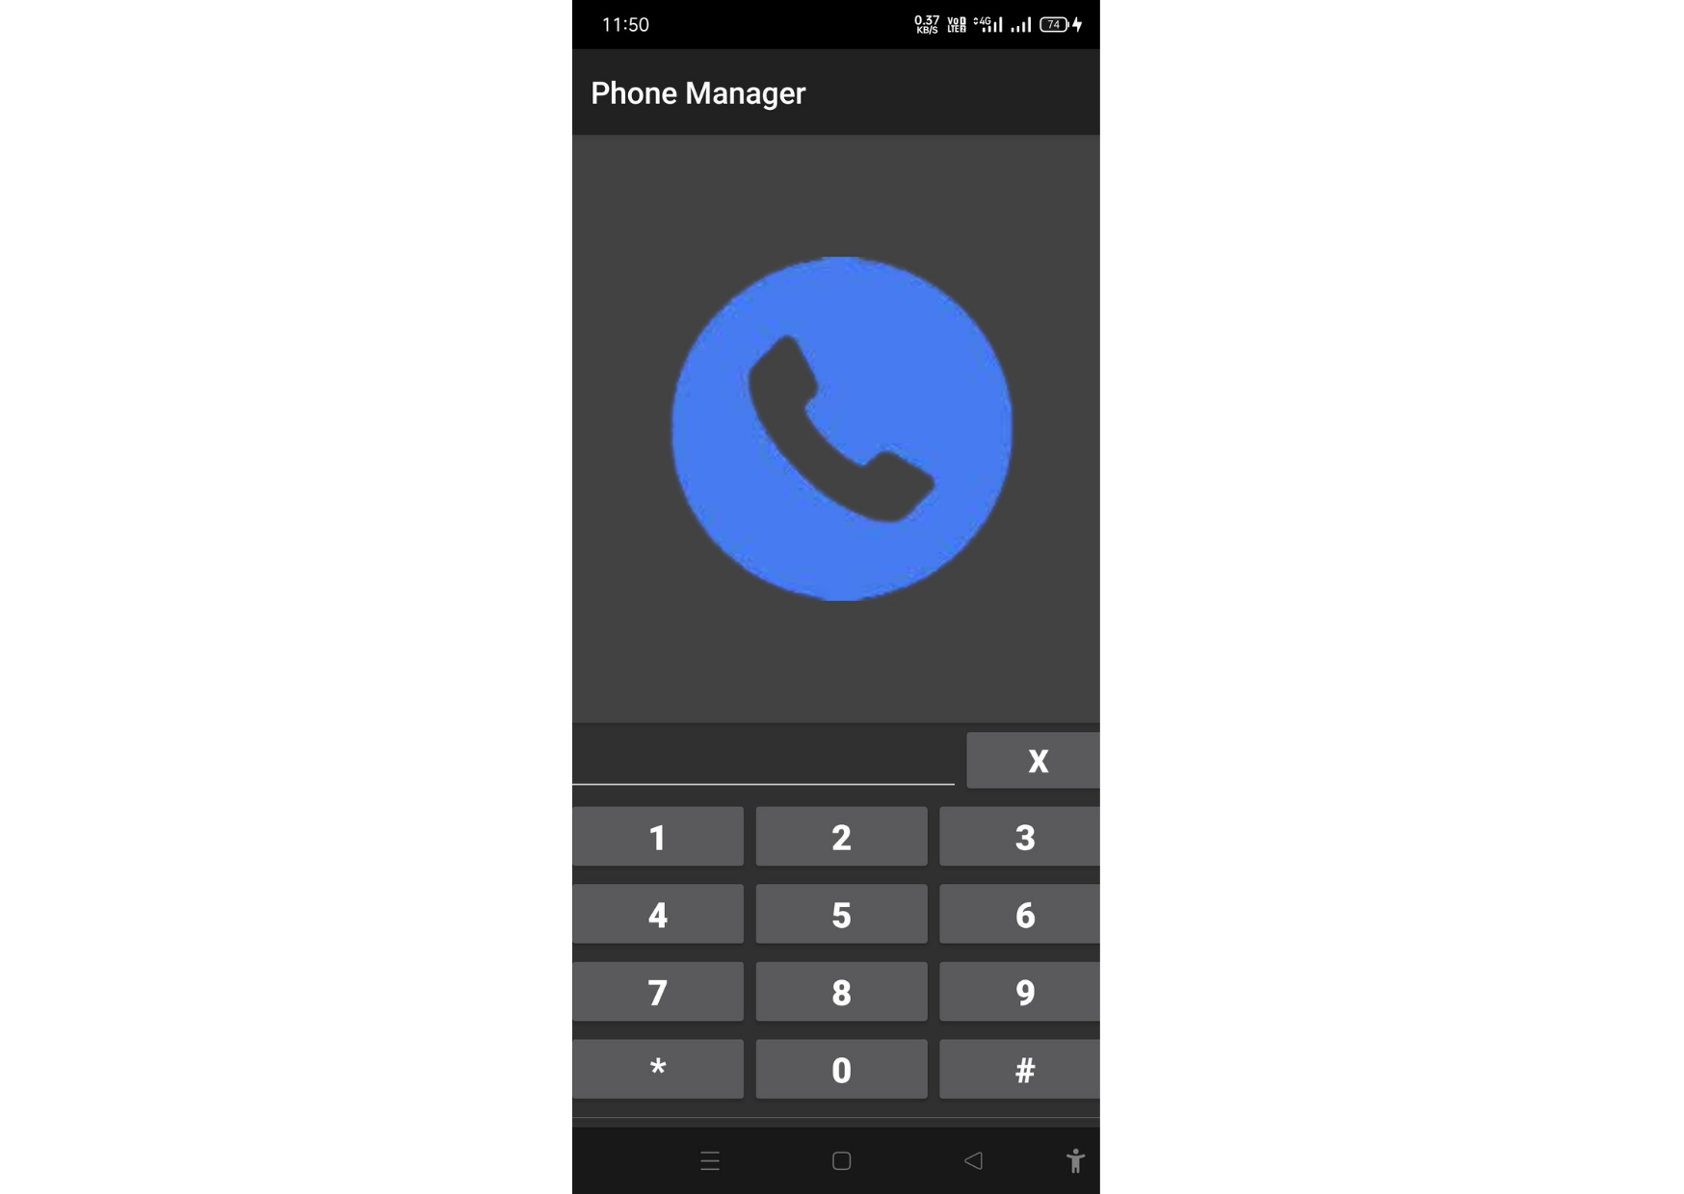 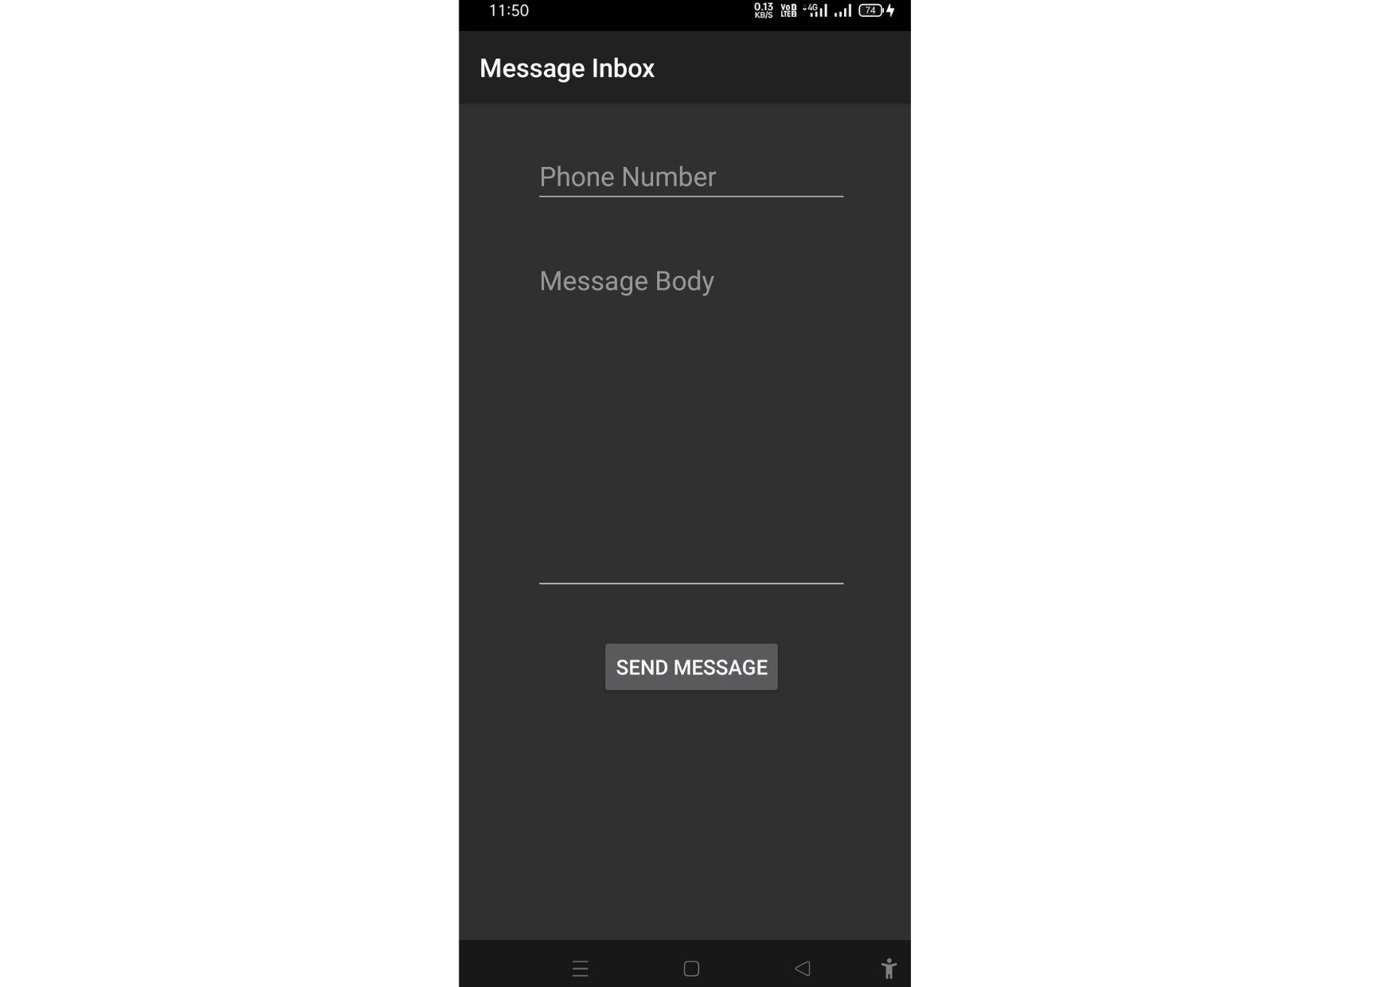

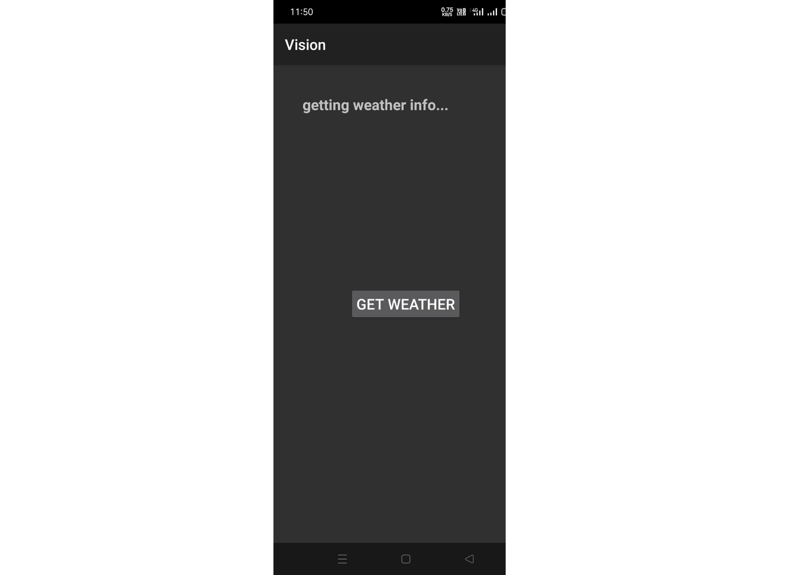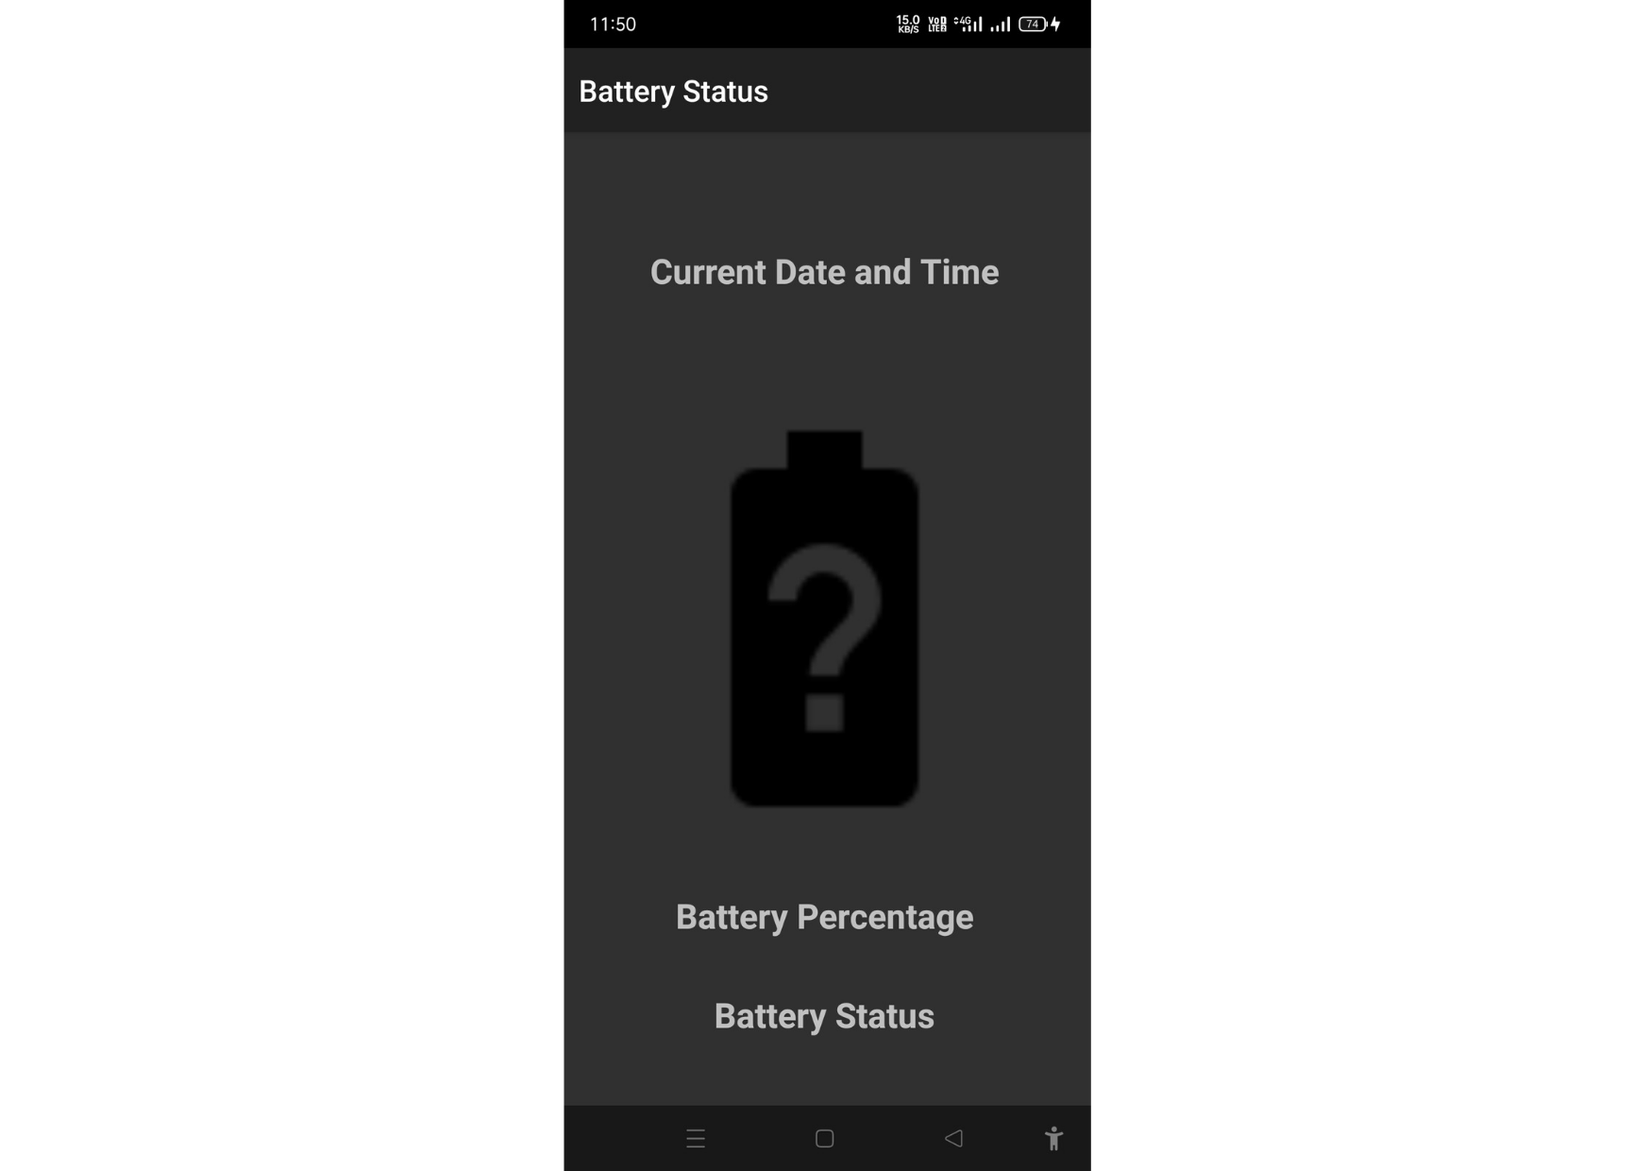

# [CHAPTE](https://1.bp.blogspot.com/-dODuK8N5h1Q/Wlnyb3V9HFI/AAAAAAAACL4/WxQtCJ1pM5wccDABg4wIrTBUB0vlikXQQCLcBGAs/s1600/poly1.jpg)R 7 CONCLUSION

**7.CONCLUSION**

The package was designed in such a way that future modifications can be done easily. The following conclusions can be deduced from the development of the project:

* Automation of the entire system improves the efficiency
* It provides a friendly graphical user interface which proves to be better when compared to the existing system.
* It gives appropriate access to the authorized users depending on their permissions.
* It effectively overcomes the delay in communications.
* Updating of information becomes so easier
* System security, data security and reliability are the striking features.
* The System has adequate scope for modification in future if it is necessary.

# REFERENCE

Aamodt, Agnar, and Enric Plaza. “Case-based reasoning: Foundational issues, methodological variations, and system approaches.” AI communications 7.1 (1994): 39-59.

Adebayo, Julius, Justin Gilmer, Michael Muelly, Ian Goodfellow, Moritz Hardt, and Been Kim. “Sanity checks for saliency maps.” arXiv preprint arXiv:1810.03292 (2018).

Alain, Guillaume, and Yoshua Bengio. “Understanding intermediate layers using linear classifier probes.” arXiv preprint arXiv:1610.01644 (2016).

Alber, Maximilian, Sebastian Lapuschkin, Philipp Seegerer, Miriam Hägele,

Kristof T. Schütt, Grégoire Montavon, Wojciech Samek, Klaus-Robert Müller, Sven Dähne, and Pieter-Jan Kindermans. “iNNvestigate neural networks!.” J. Mach. Learn. Res. 20, no. 93 (2019): 1-8.

Alvarez-Melis, David, and Tommi S. Jaakkola. “On the robustness of interpretability methods.” arXiv preprint arXiv:1806.08049 (2018).

Ancona, Marco, et al. “Towards better understanding of gradient-based attribution methods for deep neural networks.” arXiv preprint arXiv:1711.06104 (2017).

Apley, Daniel W., and Jingyu Zhu. “Visualizing the effects of predictor variables in black box supervised learning models.” Journal of the Royal Statistical Society: Series B (Statistical Methodology) 82.4 (2020): 1059-1086. Athalye, Anish, and Ilya Sutskever. “Synthesizing robust adversarial examples.” arXiv preprint arXiv:1707.07397 (2017).